MFC Paint 2000
Comp2085
GUI Programming

Submitted by:
Rodito M. Buan II
Submitted to:
Prof. Ylber Ramadani

Date:
March 17, 2000
Starting MFC Paint 2000

Run the program just by double clicking it on Windows Explorer or you can go to Start Button and then Run Button then just browse the location of the software. You will see a splash screen when you first load the program. The splash screen looks like this.

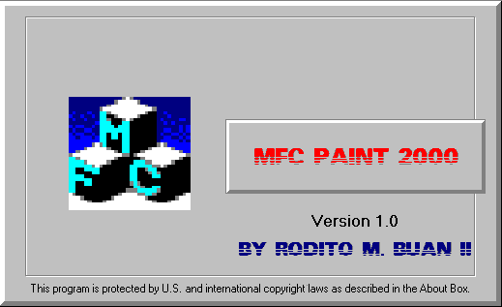

NOTE: CsplashWnd : CWnd declaration of splash screen class. So the splash screen is a window.

The Main Application

When the splash screen hides you will see the Main Application with looks like this.

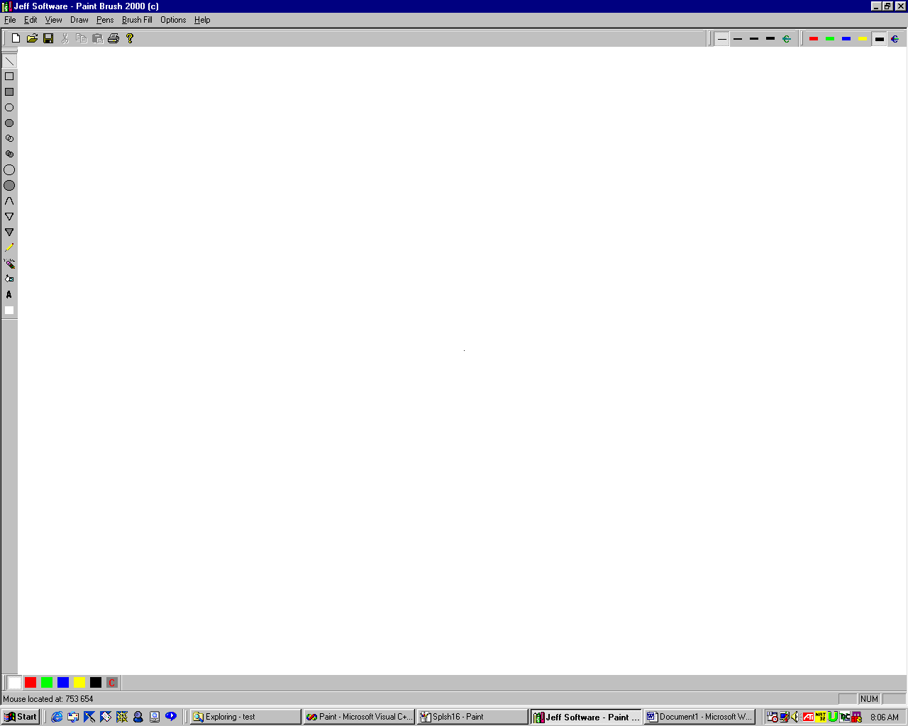

Notes: I have made the application MAXIMIZE for full usability. I have attained this by including the SW_MAXIMIZED in the ShowWindow method of Capp.

The Icon

I also change the default application icon. The Icon looks like this.
The icon
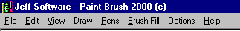

Also when you have the icon on the desktop. It looks like this.
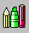
Also when you look at the application version on the properties. You will see this.
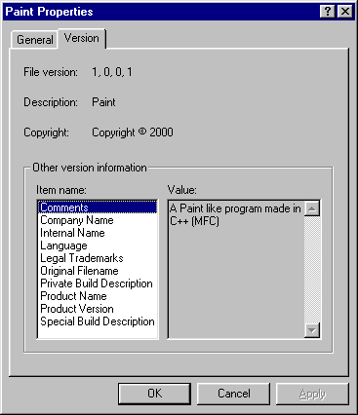

The Cursors

I have change the application cursor, drawing line cursor, drawing freehand cursor, and eraser cursor.

Application Cursor:
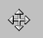

Drawing Line Cursor:
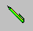

Drawing Freehand Cursor:
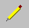

Eraser Cursor:
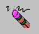

The Toolbars, ReBar and Statusbar

I have five toolbars and three of them is in the ReBar, and two can be docked / float.

The Tools Toolbar:
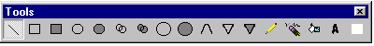

The Background Brush Toolbar:
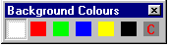

The ReBar:
The ReBar has three toolbar in it.
Its looks can be also change like IE 5.
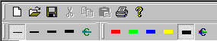

The Statusbar:
The right side:
The left side:

How to Use the program.

To draw a line simply click on the Line Image at the Tools Toolbar and press your left mouse button down and drag it to how long you want the line to be and release the left mouse button. This all applies to drawing rectangles, ellipse, oval, arc, pie, round rectangle, eraser, and freehand. To create a text simply click on the A image button on the Tools toolbar. You will be prompt for a Font Dialog box.
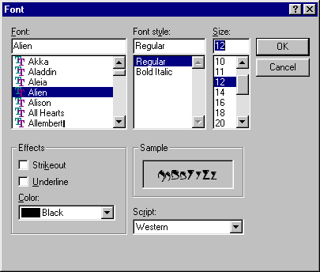 After this, you should click on the Client Area where you want the text to be displayed. You will then again be asked to type what text you want to be displayed on another Dialog box.
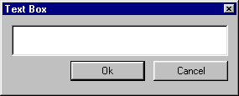 After you click ok, your text will be displayed. To fill drawings simply click on the Fill Image on the Tools Toolbar. You will then be prompt for a Colour Dialog box, which you can either select what custom brush you want or use the default selected brush. See Image next page.
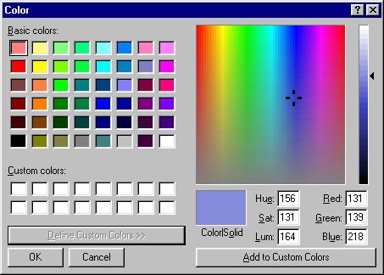
- To change brush colours, simply press one button in the Brush Background Toolbar.
- To change pen colours, simpley press one button in the Pen Color Toolbar located at the ReBar.
- To change pen sizes, simply press one button in the Pen Size Toolbar located at the ReBar.
- You can also enter custom sizes by clicking on the Custom size image on the Pen Size Toolbar. You will be prompt for a Dialog box that has a slider control on it that you can drag and change. 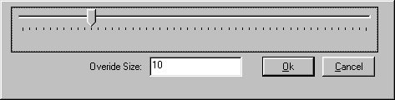 You can then override the custom size by typing a value lower to the slider control at the Edit box.
- You can show and hide toolbars at the Option menu.
- You can choose your termination button at the Option menu too.
- You can enable Undo/Redo on the Option menu.
- You can fix the Flickering on the Option menu.
- You can show the splash screen on the Option menu.
- You can zoom in, zoom out and reset using the View menu.
- You can use undo / redo using the Edit menu.
- You can Save, Create New, Open, Setup Printer, and Exit using the File menu.
- Also this entire menu item has a default menu trigger and accellerators.
- The menu items dynamically checks and unchecks whenever you check an item. 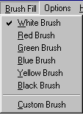 The toolbar items dynamically press and unpress whenever you press a button.
- You can also view the About and the infamous Credits using the Help menu. 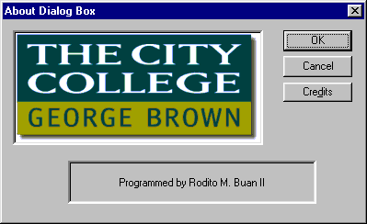 and 